Tutorial 14

Q.1 Store the Weighted Graph presented in below figure (Fig. 1) using Adjacency Matrix and Adjacency List.

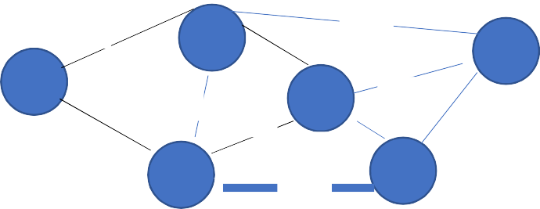

10

B

20

E

A

18

D

2

A

30

12

6

15

C

F

16

Fig. 1

Q2. Using Breadth First Search, it is desired to find out the minimum number of edges required to traverse from Node A to Node P (Fig. 1 of Q1). Write a program to perform the desired task. Also discuss the list of data structures used to perform the desired task.

Q3. It is desired to find out all the paths to traverse from Node A to Node P (Fig. 1 of Q1). Write a program to perform the desired task. Also discuss the list of data structures used to perform the desired task.

Q4. It is desired to find out the minimum cost required to traverse from Node A to Node P (Fig. 1 of Q1). Write a program to perform the desired task. Also discuss the list of data structures used to perform the desired task.

Q5. Find out the Minimum Spanning Tree of the weighted graph given in Fig. 1 using Kruskal’s algorithm and Prim’s algorithm. Write a program to perform the desired task. Also discuss the list of data structures used to perform the desired task. Evaluate the performances of both approaches (Prim’s and Kruskal’s) in finding the MST